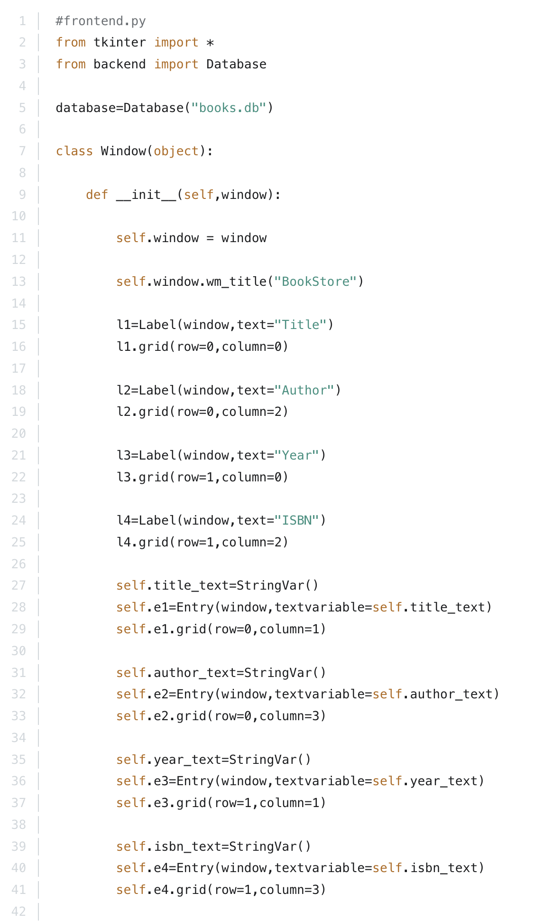
Here are the frontend.py and backend.py scripts in OOP style. To execute this program, you should execute the frontend.py file.

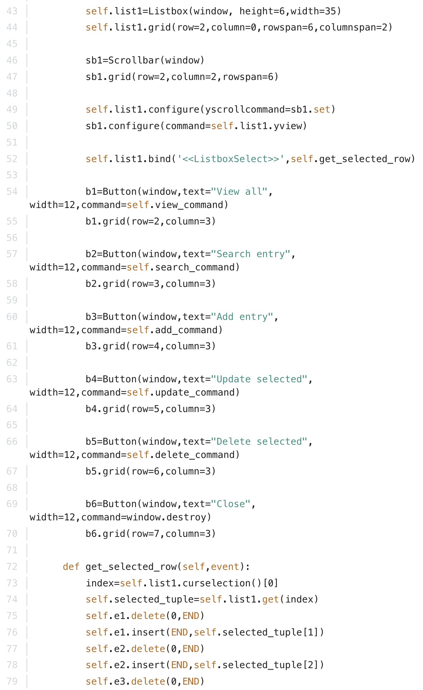

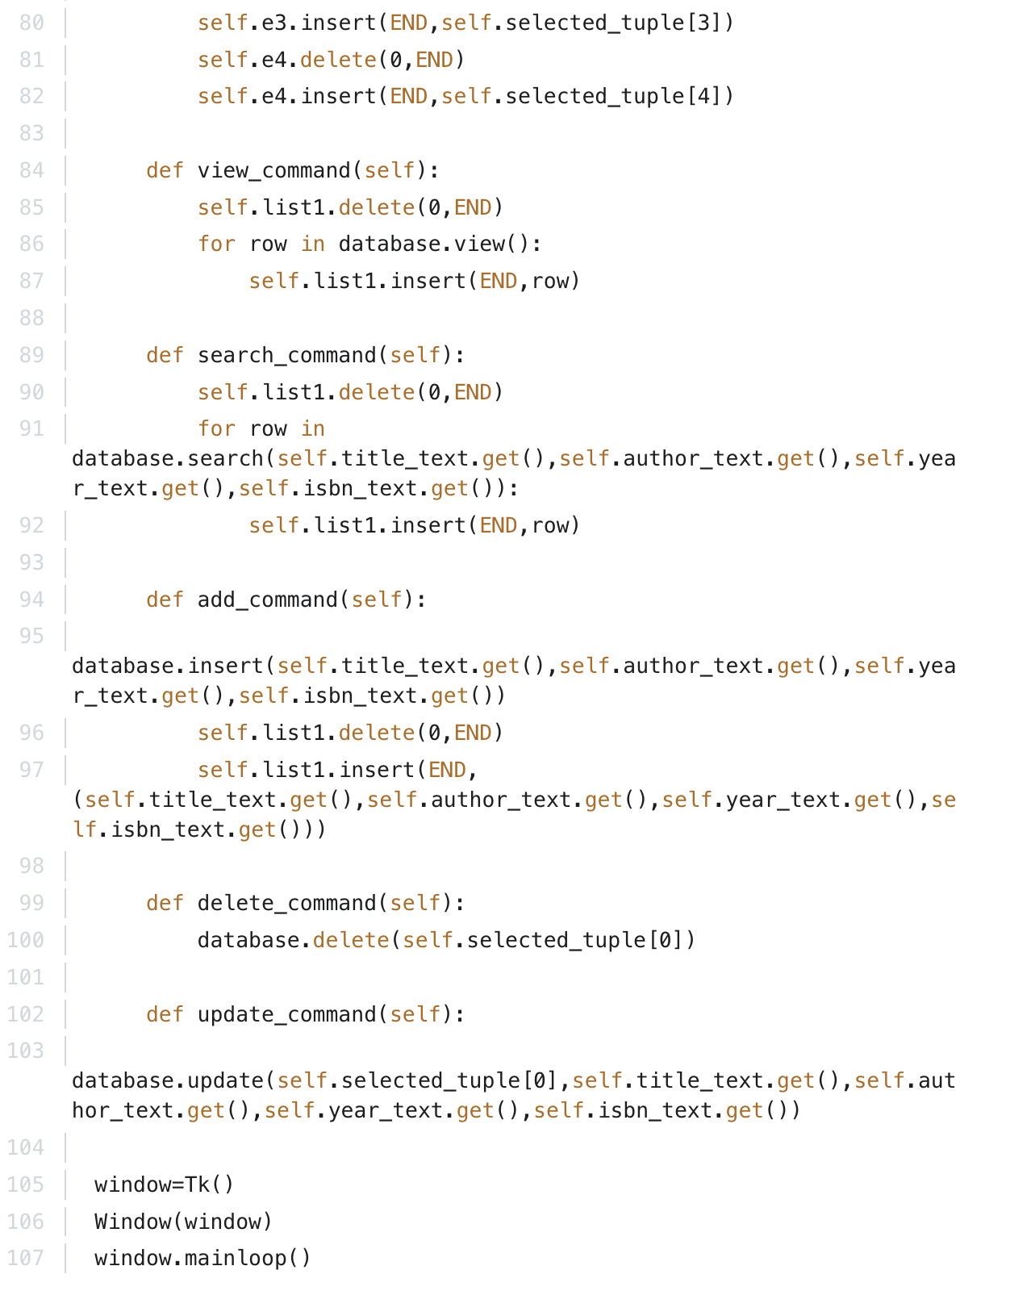

And below, you will also find the backend.py script in OOP:

